**Measurement 1**

Comprises of length, area, volume, mass, density and time

**SI Units**

Universal System of Units is called **system international d' unites** (International System of Units) - SI Units.  
Below are the major SI Units

|  |  |  |
| --- | --- | --- |
| **Basic Quantity** | **SI Unit** | **Symbol** |
| Length | Metre | m |
| Mass | Kilogram | kg |
| Time | Second | s |
| Electric Current | Ampere | A |
| Thermodynamic | Kelvin | K |
| Luminous Intensity | Candela | Cd |
| Amount of Substance | Mole | mol |

**Length**

- The distance between two fixed points.  
- The S.I Unit is **Metre (M)**  
Derived units are shown below

|  |  |  |
| --- | --- | --- |
| **Unit** | **Symbol** | **Equivalence in Metres** |
| Kilometre | Km | 1000 |
| Hectometre | Hm | 100 |
| Decametre | Dm | 10 |
| Decimetre | dm | 0.1 |
| Centimetre | Cm | 0.01 |
| Millimetre | mm | 0.001 |
| Micrometre | µm | 0.000001 |

*Estimating the length of a tree*  
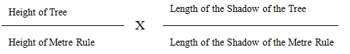

**Area**

- measures the surface area covered by a body  
- Its unit is **m2**.

Can you convert 15.5M2 to cm2?  
  
*Solution*  
1m = 100 cm  
1m2 = 100 cm x 100 cm = 10000 cm2  
15.5 m2 = 15.5 x 10000 cm2  
= 1550000 cm2

**Area of a regular body**

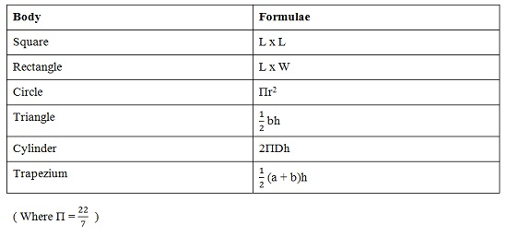

**Area of an irregular body**

The squares must be 1cm2 each.  
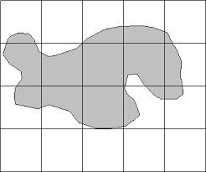  
**Area**  
Full Squares = .... cm2  
½ x Incomplete squares = .... cm2  
Area = Full Squares + (½ x Incomplete squares)

**Volume**

- measures the amount of space occupied by a body  
- Its unit is **m3**.

Can you convert 4.5m3 to cm3 ?  
  
Remember: 1m3 = 100cm x 100cm x 100cm = 1000000 cm3

**Volume of a regular body**

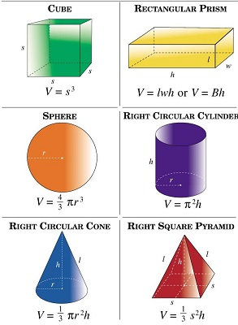  
NB: Liquids can be measured by putting them into containers with sizes of graduated objects such as Graduate Cylinder, Syringe, Buret and others

**Volume of an irregular body**

It can be done using a **Measuring Cylinder** or a **Eureka Can**.

**Measuring Cylinder**

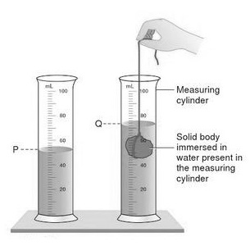  
Volume = Q (V1) - P (V2)

**Measuring Cylinder**

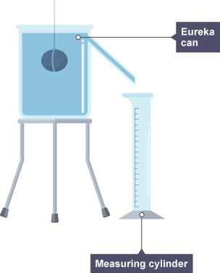  
Volume will be read on the measuring cylinder.

**Mass**

- Quantity of matter in a body. SI units is Kilogrammes (Kg)  
Mass can be measured using:-

* Top Pan Balance
* Beam Balance
* Lever Balance

**Density**

- Mass per unit volume. Its symbol is rho (ρ). Its SI Unit is Kilogramme per Cubic Metre (Kg/m3)

A block of stone has a mass of 140g and is 10cm long, 5 cm wide and 4 cm high. Calculate the density of the stone

*Solution*  
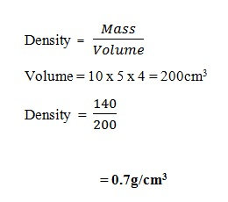

**Density Using a Density Bottle**

The mass of a density bottle is 20g when empty and 45g when filled with water. When filled with liquid x, its mass is 400g. Calculate the density of liquid x. (density of water 1.0 g/cm3)

*Solution*  
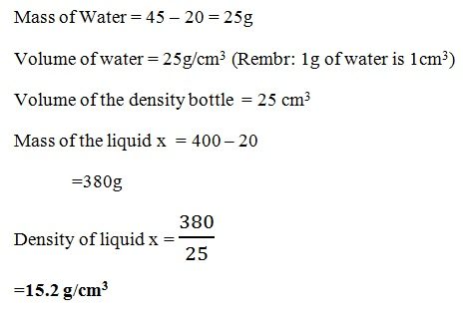

**Relative Density**

**Relative density** (RD) is the ratio of the density of a substance to the density of water. It is also known as **specific gravity** (SG).  
- if the value is **less than 1**, it is less dense than water and would float  
- if the value is **equals to 1**, it has the same density as water  
- if the value is **greater than 1** it is more dense than water and would sink.